**How A Crystal Radio Works**

**"Modulated" Wave (signal)**

**Now we have this radio wave flying through the air hitting everything! That's right including you! Radio waves can travel at 186,000 miles a second in the air!  
  
Interesting fact: a sound wave travels over 600 miles an hour (speed of sound), but a radio wave can travel at 186,000 miles a second! If you record a singer in a concert hall in New York and transmit it over radio waves, The radio wave could reach San Francisco before the sound wave from the singer reaches the back of the concert hall.  
  
  
 We have to catch it and do something with it. Let’s take your crystal radio and see if we can change it back into a sound that you can hear.**

**The Crystal Radio Receive**

**We are going to use a very simple crystal radio for this explanation. Figure #4 below shows a very simple crystal set. A small amount of energy from the radio wave is captured by the antenna wire and is taken to the coil. The coil has to be designed just right to capture only the frequency we are trying to receive. In our case we are trying to receive our radio station above at 610 kHz. By winding just the right amount of wire on just the right diameter coil form, the coil will be what we call "resonant" and "ring". In other words it will be able to store the energy of the radio wave we want to hear.  All other radio waves not "resonant" will pass through the coil and out the other side to the ground.**

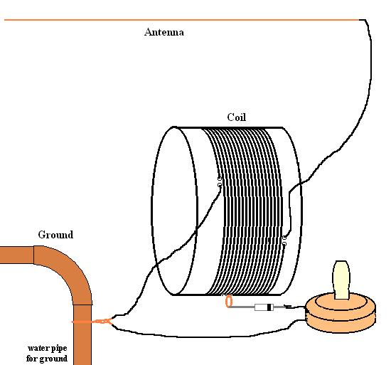

**Figure #4**

**A small amount of the radio wave energy stored in the coil (our 610 kHz or 610,000 cycles per second) moves to the detector or the device called a diode. The energy is an alternating current signal (AC) at this point. The detector (diode) rejects half of the alternating current signal and the signal looks like figure #5 below. Now the signal is a pulsating direct current (DC) signal.**

**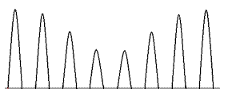  
Figure #5  
This allows the earphone to use the energy. If both sides of the wave were used, they would cancel each other out as they are opposite of each other. As this energy go into the earphone, the amplitude or strength of the signal varies because the wave is "modulated". This energy is converted by mechanical means in the internal workings of the earphone. The sound waves exit the earphone which you perceive as the original sounds from the radio station.  
  
Not discussed here is tuning the coil to get different frequencies. That can be done by adding more turns of wire around the coil form. Or removing some. On a simple radio, this is done by moving the diode up or down the taps on the radio in effect making the coil longer or shorter. This changes the "inductance" of the coil or makes it resonant to different frequencies.  
  
Another way to do this is to add a variable capacitor across the coil. This adds or removes capacitance to the coil and changed the resonant frequency the coil will tune to.**